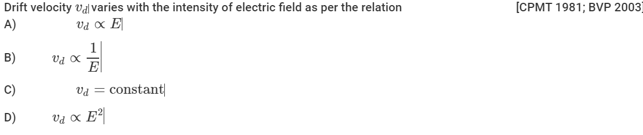
Ques:

Ans:
- v_{d} = (e/m).(V/l)t where t is relaxation time. Using V = El we get v_{d} is proportional to E

